**Prodigy InfoTech Internship:**

**Task-2**

Perform data cleaning and exploratory data analysis (EDA) on a dataset of your choice, such as the Titanic dataset from Kaggle. Explore the relationships between variables and identify patterns and trends in the data.

Sample Dataset: [Titanic](https://www.kaggle.com/c/titanic/data)

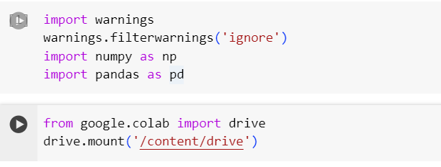

**2 Understand the shape of the data**

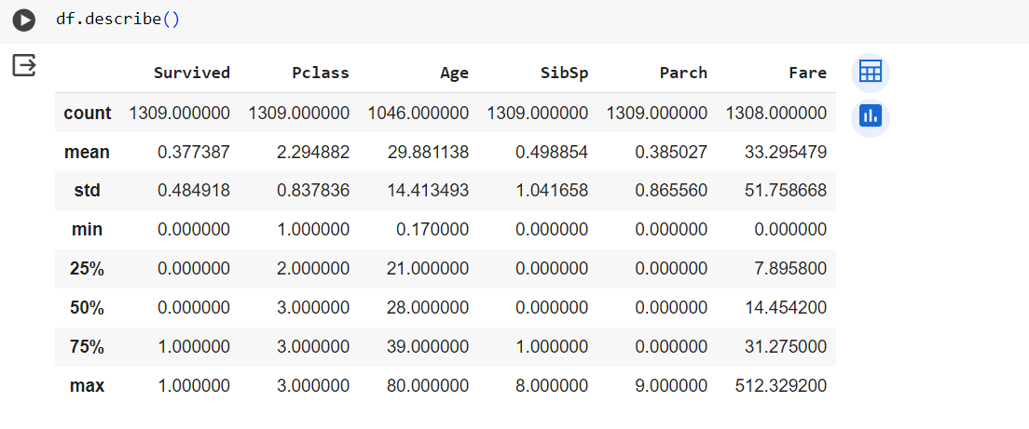

**3 Data Cleaning**

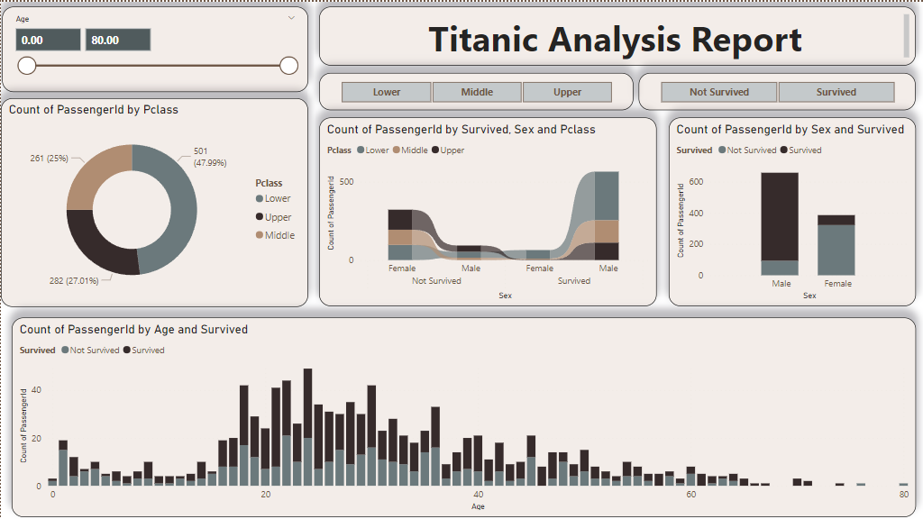**4 Data Visualization using** [**Power BI**](https://app.powerbi.com/links/WoLo3LZbmg?ctid=53bc88e9-b6c4-4d8e-8def-e26514fb6c59&pbi_source=linkShare)